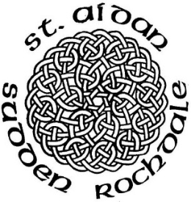
St Aidan’s Church is part of the vision of the Diocese of Manchester to be a worshipping, growing, transforming Christian presence at the heart of our community.

The work of churches across the Diocese is centred on four key themes: Parish Renewal, Growing Younger, Church Planting and Revitalisation, and Developing Missional Leaders.
Parish Renewal


At St Aidan’s, we have been given a special opportunity to participate in Parish Renewal. This initiative is designed to help our church grow in mission, spirituality, numbers and financial sustainability. This includes us all but we need new volunteers who can champion fresh ideas and help equip our church for the future.

Can you help?
Would you like to find out more about how you can get involved? If so, please speak to Revd Sydwell or any member of the PCC.

…………………………………………………………………………………………………………………………

Name ………………………………………………………………………………
I would like to get involved with Parish Renewal
I am already involved with Parish Renewal as a PCC Member
Although I am not able to volunteer at the moment,
I will keep Parish Renewal at St Aidan’s in my prayers.

