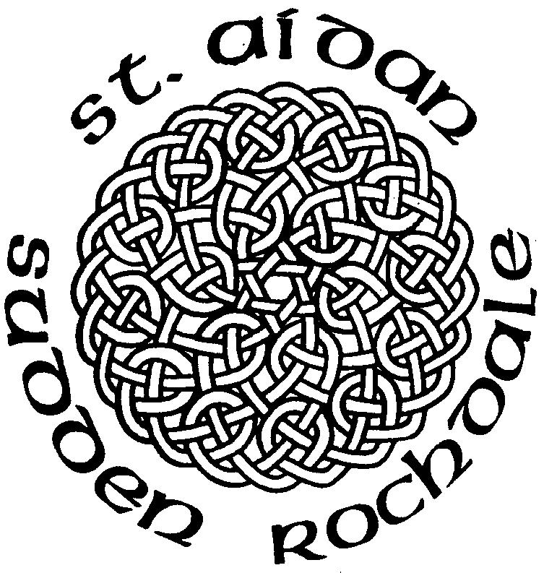


25th Nov 2012
Christ The King

Anthems

Laudate Omnes Gentes
Taize
From The Rising Of The
Sun
Ouseley

Weekly Services
Sundays:
10am - Family Communion
Wednesdays:
9.30am - Holy Communion

Weddings and Baptisms
by appointment

St. Aidans Church
Sudden, Rochdale

Contact Us

Vicar
Rev Michael Read
41 Harold Lees Road
Heywood, OL10 4DW
Tel: 01706 360693 vicar@staidan.org.uk

Churchwardens:
Malcolm Bywater
168 Bury New Road,
Heywood
Tel: 01706 623546
malcolm@staidan.org.uk

John Tolley
11 Binns Nook Rd., Syke
Tel: 01706 527973
john@staidan.org.uk

Verger & Deputy Churchwarden
Ronnie Ogden
22 Ashley Close
Tel: 01706 630651

Hall Bookings
Andrew Huxley
4 Birchfield Drive
01706 658206
andrew@staidan.org.uk

PCC Secretary
Ann Montgomery
5 Briar Close, Norden
Tel: 01706 359869
ann@staidan.org.uk

Treasurer:
Debra Buckley
14 Broadhalgh Road,
Tel: 01706 647703
debra@staidan.org.uk

Events Diary
November
Sun | 18th | 2– 5 pm | 100th Birthday celebration
Sun | 18th | 6.30pm | Confirmation Service at St Martin’s
Tues | 20th | 2pm and 7.45pm | TWAM Roadshow
Fri | 30th | 7.00pm | St Aidan’s Banquet
December
Sat | 1st | 7.00pm | St Aidan’s Banquet
Sun | 2nd | 6.30pm | St Aidan’s Advent Carol Service
Fri | 7th | 7.00pm | St Aidan’s Banquet
Sat | 8th | 7.00pm | St Aidan’s Banquet
Sat | 8th | 7.30pm | Community Ch Concert at St Leonard’s
Sun | 16th | 10.00am | St Aidan’s Childrens Christmas Service
Sun | 16th | 6.30pm | Masonic Carol Service
Thurs | 20th | 7.30pm | Magistrates Carol Service
Sun | 23rd | 6.30pm | St Aidan’s Carol Service

Regular Events

Open Church – 1st, 3rd & 5th Wednesdays 10am-4pm
St Aidan’s Art Group – Mondays 12.45pm
Choir Practice – Thursdays 7pm/7.45pm
FairTrade Stall – last Sunday of the month
St. Aidan’s Men’s Group – 1st Weds of the month
St. Aidan’s Ladies Guild – monthly meetings
St Aidan’s Flower Group – Fridays 7.30pm
Knitwits – Fridays 2pm
Councillor’s Surgery – 1st Saturday 10.15am
Coffee Morning at All Souls – 2nd Sat. 10.30am
Messy Church at All Souls – last Sat. 10-11.30am
Gospel Reading

John; 33 - 37

St. Aidan’s C of E Parish Church
Manchester Rd Rochdale OL11 2EL
Vehicular Access OL11 3NH
www.staidan.org.uk

MANY THANKS
Many Thanks to everyone who made my party such a fantastic do.It was a very tiring day but I enjoyed it all. I have received loads of cards including one from the Queen. Had another party on Thursday and another due on Tuesday ……..Quite a week
THANK YOU ALL
Sylvia
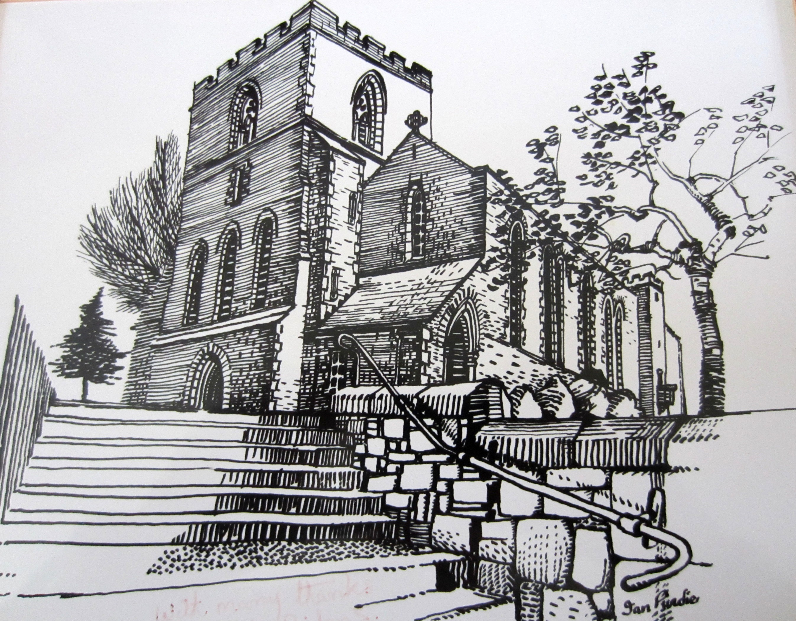

This morning we mark our Patronal Festival as this is the Sunday nearest to St Luke’s Day (18th Oct).
On St Luke’s Day 1913, the Foundation Stone was laid by Lady Rochdale and we will be celebrating the centenary of this event next year.

Refreshments are served in the Hall after the Service.

JUNIOR CHURCH: our Children’s Groups meet in the Hall
during the Morning Service: Kindergarten (3-6);
Adventurers & Explorers (7 –14)

GIFT AID LEGISLATION
If you are a taxpayer and don’t at present make use of the weekly envelope scheme, kindly use the Gift Aid Envelopes you will find near your seat. We will then be able to claim 25p for every £1 you give. Please remember to fill in your name and address.

INTERCESSIONS
Please add names for the Intercessions in the book at the back of Church.

Welcome to St Aidan’s Church
We are a friendly caring church.
If we can help you in any way, please speak to the Vicar, Sidespersons or any of the Church Officers.

DUTIES NEXT WEEK: 2nd Dec Advent Sunday

Sidespersons | Young Stewards, Ina Penneyston
Coffee rota | A Parry, B Whitehead, L Hutton
Hall preparation | R Ogden, A Huxley
Junior Church | Pam, Julie B, Hollie | Julie B & Ros
Open Church | Please check rota
Church Cleaning

Please email notices to newsletter@staidan.org.uk by noon on Weds and if you wish this notice sheet to be emailed to you every week, please contact newsletter@staidan.org.uk
Please send items for the website to webmaster@staidan.org.uk

REBEKAH’S FUND RAISING
FIZZ & JAZZ
Fashion event at Shaw Conservative Club Queen St Oldham OL2 8RW
Thurs 6th Dec at 7.30 pm, Tickets £3
Please see poster at back of Church
FESTIVE CHEER
Please come & join Debra and Jonathan Buckley for mulled wine & mince pies & nibbles etc at 14 Broadhalgh Rd Bamford on Sun 23 rd Dec from 8.00pm(after the 6.30 pm service of Nine Lessons and Carols)
Tickets £5 available from Debra ( limited No )

THE BANQUETS
All the banquets are now SOLD OUT, If you have applied for tickets and not yet paid, your money would now be helpful to enable us to buy the food & drink !!!!!. Many Thanks

OPEN CHURCH
Desperately seeking Volunteers for 5th Dec Please see rota at the back of Church .No Open Church in Jan
HELP REQUIRED
Can you help, volunteers are required for routine maintenance tasks in Church, if you can help please e mail john@staidan.org.uk or speak to John Tolley

CHRISTMAS TREE
Optional Way To Send Your Christmas Greetings
There will be a Christmas Card Tree at the back of Church from Advent Sun 2 nd Dec. If you wish you can place one card on the tree to greet all your friends at St Aidan’s. Perhaps with the money saved from buying one card instead of many, you may wish to make a donation to either a charity of yor own choice or gift aid to St Aidan’s

ST AIDAN’S LADIES
Wednesday 28th November at 7.30pm
Craft Workshop
All are welcome

MANY THANKS
The family of Alfredo Cocciadiferro would like to thank Elizabeth for playing the organ and the Choir for their beautiful singing as well as the altar flower cascade of yellow roses, at his memorial service on Fri 9th Nov.
Thanks also to Rev Mike Read for his sensitive ministry

