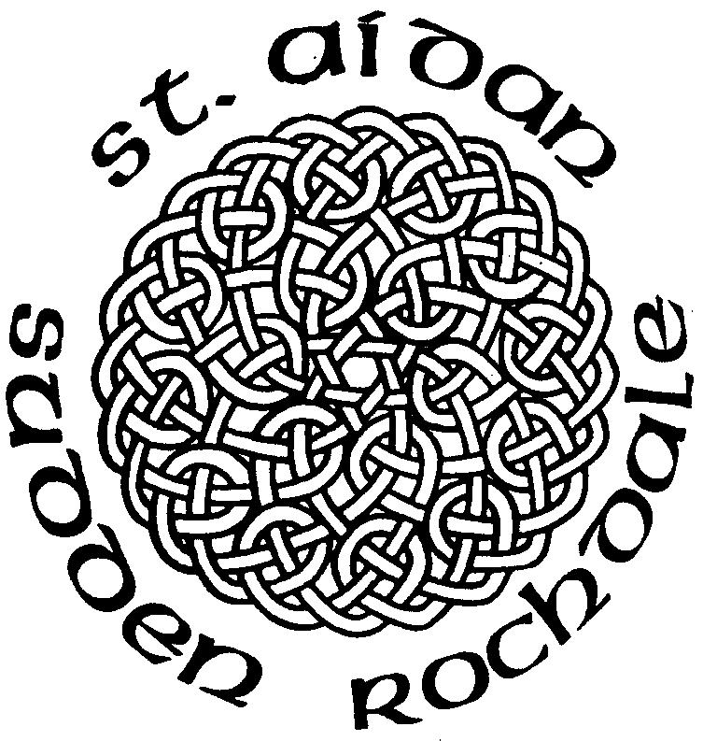
St. Aidans Church
Sudden, Rochdale

Contact Us

Vicar
Rev Michael Read
26 Heywood Hall Road
Heywood, OL10 4UU
Tel: 01706 360693 vicar@staidan.org.uk

Churchwardens:
Malcolm Bywater
168 Bury New Road,
Heywood
Tel: 01706 623546
malcolm@staidan.org.uk

John Tolley
11 Binns Nook Rd., Syke
Tel: 01706 527973
john@staidan.org.uk

Verger & Deputy Churchwarden
Ronnie Ogden
22 Ashley Close
Tel: 01706 630651

Hall Bookings
Andrew Huxley
4 Birchfield Drive
01706 658206
andrew@staidan.org.uk

PCC Secretary
Ann Montgomery
5 Briar Close, Norden
Tel: 01706 359869
ann@staidan.org.uk

Treasurer:
Debra Buckley
14 Broadhalgh Road,
Tel: 01706 647703
debra@staidan.org.uk

Events Diary
September
Sat | 29th | 2.00pm | National Day of Prayer & Praise at Wembley
Sun | 23rd | 10am | Celebration of the 60th Anniversary of the Dedication of the Organ
Sun | 30th | 10am | Harvest Festival  Back to Church Sunday
October
Sat | 6th | 8.45am | Walking Group
Sat | 20th | 11am -1pm | Autumn Craft Fair & Coffee Morning

Regular Events

Open Church – 1st, 3rd & 5th Wednesdays 10am-4pm
St Aidan’s Art Group – Mondays 12.45pm
Choir Practice – Thursdays 7pm/7.45pm
FairTrade Stall – last Sunday of the month
St. Aidan’s Men’s Group – 1st Weds of the month
St. Aidan’s Ladies Guild – monthly meetings
St Aidan’s Flower Group – Fridays 7.30pm
Knitwits – Fridays 2pm
Councillor’s Surgery – 1st Saturday 10.15am
Coffee Morning at All Souls – 2nd Saturday 10.30am
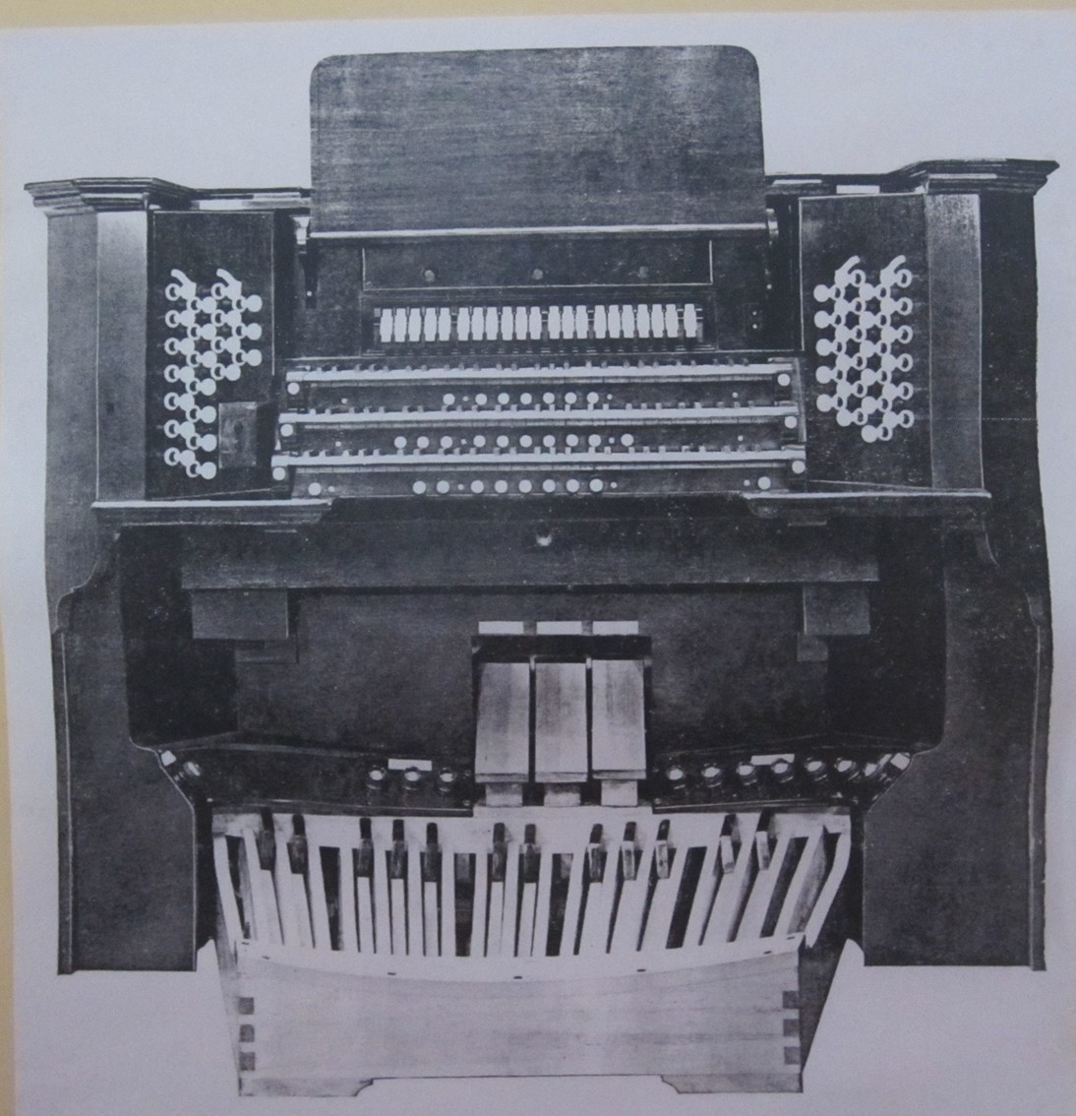
16th Sept 2012

Trinity 15

Anthem

Weekly Services
Sundays:
10am - Family Communion
Wednesdays:
9.30am - Holy Communion

Weddings and Baptisms
by appointment


St. Aidan’s Cof E Parish Church
Manchester Rd Rochdale OL11 2EL
Vehicular Access OL11 3NH
www.staidan.org.uk
Gospel Reading
Mark 8 27 - end

The Father Willis Organ.
We will be celebrating the 60th Anniversary of the Dedication of the Organ on Sunday 23rd September.
METAL THEFTS There have been thefts of lead from the church roof in the past fortnight. This caused extensive problems last week with the disruption to the power supply to the Hall and then water damage in the Organ Loft and Chapel discovered after the heavy rain last weekend. The cost of repairs will not be fully covered by Insurance.
Many thanks to all who repaired the damage.

AUTUMN FAIR SAT 20TH OCT – 11am – 1pm
5 WEEKS TO GO
There will be a number of craft stalls, children’s activities, side-shows and games. Items for the tombola would be appreciated as well as smaller gifts, toys, sweets etc for lucky dip prizes. Joanne Elcock is collecting them. Also if you can help in any way please sign up on the sheet in the hall foyer or see Joanne.

Coffee and Tea is served in the Hall after the Service

INTERCESSIONS
Please add names for the Intercessions in the book at the back of Church.

Welcome to St Aidan’s Church
We are a friendly caring church.
If we can help you in any way, please speak to the Vicar, Sidespersons or any of the Church Officers.

GIFT AID LEGISLATION
If you are a taxpayer and don’t at present make use of the weekly envelope scheme, kindly use the Gift Aid Envelopes you will find near your seat. We will then be able to claim 25p for every £1 you give. Please remember to fill in your name and address.
DUTIES NEXT WEEK: 23rd September - Trinity 16

Sidespersons | A&J Clarke, L Hutton, J Hornby
Coffee rota | V Hardy, M Benjamin, M Worsley
Hall preparation | J Tolley, K Lloyd
Junior Church | Deborah, Rachel, Andrew, Tracey
Open Church | 19 Sep: Malcolm, John, Mike, Paul (am); Alan, Ina (pm)
Church Cleaning

Please email notices to newsletter@staidan.org.uk by noon on Weds and if you wish this notice sheet to be emailed to you every week, please contact newsletter@staidan.org.uk
Please send items for the website to webmaster@staidan.org.uk
JUNIOR CHURCH: our Children’s Groups meet in the Hall
during the Morning Service: Kindergarten (3-6)
Adventurers & Explorers (7 –14)

HERITAGE OPEN DAYS – Thank you to all volunteers who helped keep the church open for these 3 days. We had a number of visitors.
ALPHA COURSE AT BAMFORD CHAPEL commences Monday 24th September at 7pm for 12 weeks. There is a meal, DVD & a chat. It is a free course with a donation towards food. See Oliver’s Mum (aka Rachel!) or poster for more info. Launch event Mon 17th Sept 7pm, Queens Park Cafe. Course open to anyone who hasn’t attended an Alpha course before.
OPEN CHURCH - Thanks to those who have 'church sat' in recent months, we have had some interesting visitors. We are appealing for help -
there are still a number of spaces in the months to the end of the year. Please consider what other jobs you do around or for church; could you do these whilst church sitting on Wednesdays? Ideally there should be two sitters per session. Please put your name on the sheet at the back of church if you are able to help. Many thanks, the PCC.

ST AIDAN'S BANQUETS 2012 - Banquet Rehearsals are now underway on Sundays at 7-9 pm in the Hall. If you would like to be involved in any way in the entertainment please come along and find out what is happening.

See Sheila Tolley if you can help with food preparation or washing up.

WATERCOLOUR PAINTING GROUP : The group resumed operations on Monday, 10th September at 12.45p.m. As previously stated, numbers are small and so we would welcome any prospective newcomers. Please let Malcolm Hardy know (410093 or malchardy@sky.com) if you intend to join us.
BLAST FROM THE PAST – big thank you to all whom were involved in any way. Nearly 100 people enjoyed a super evening and church funds benefited by £810.

WALKING GROUP - October 6th Val, Harry, Ronnie and Elaine will be leading a 5 mile circular walk through Burrs Country Park and Summerseat. There will be a refreshment stop at Summerseat garden centre.
Please note a change of date for the November walk It will now take place on Sat 10th. Lynne and Bill will be leading this walk. Further details soon.
Both walks meet at 8 45am in church car park.

