
St. Aidans Church
Sudden, Rochdale

Contact Us

Vicar
Rev Michael Read
26 Heywood Hall Road
Heywood, OL10 4UU
Tel: 01706 360693 vicar@staidan.org.uk

Churchwardens:
Malcolm Bywater
168 Bury New Road,
Heywood
Tel: 01706 623546
malcolm@staidan.org.uk

John Tolley
11 Binns Nook Rd., Syke
Tel: 01706 527973
john@staidan.org.uk

Verger & Deputy Churchwarden
Ronnie Ogden
22 Ashley Close
Tel: 01706 630651

Hall Bookings
Andrew Huxley
4 Birchfield Drive
01706 658206
andrew@staidan.org.uk

PCC Secretary
Ann Montgomery
5 Briar Close, Norden
Tel: 01706 359869
ann@staidan.org.uk

Treasurer:
Debra Buckley
14 Broadhalgh Road,
Tel: 01706 647703
debra@staidan.org.uk

Events Diary
September
Fri-Sun | 7th-9th | 2-4pm | Heritage Open Days
Sat | 8th | 7pm  for 7.30pm | “Blast from the Past”  Entertainment by Nicky Markham & Evening Meal
Sat | 29th | 2.00pm | National Day of Prayer & Praise at Wembley
Sun | 23rd | 10am | Celebration of the 60th Anniversary of the Dedication of the Organ
Sun | 30th | 10am | Harvest Festival  Back to Church Sunday
Sat | 6th | 8.45am | Walking Group
Sat | 20th | 11am | Autumn Craft Fair & Coffee Morning

Regular Events

Open Church – 1st, 3rd & 5th Wednesdays 10am-4pm
St Aidan’s Art Group – Mondays 12.45pm
Choir Practice – Thursdays 7pm/7.45pm
FairTrade Stall – last Sunday of the month
St. Aidan’s Men’s Group – 1st Weds of the month
St. Aidan’s Ladies Guild – monthly meetings
St Aidan’s Flower Group – Fridays 7.30pm
Knitwits – Fridays 2pm
Councillor’s Surgery – 1st Saturday 10.15am
Coffee Morning at All Souls – 2nd Saturday 10.30am
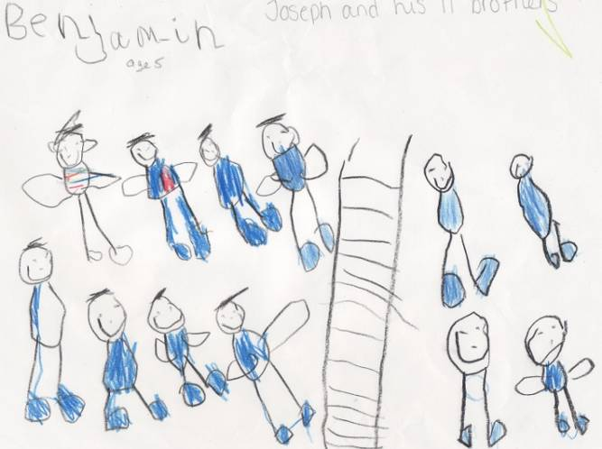
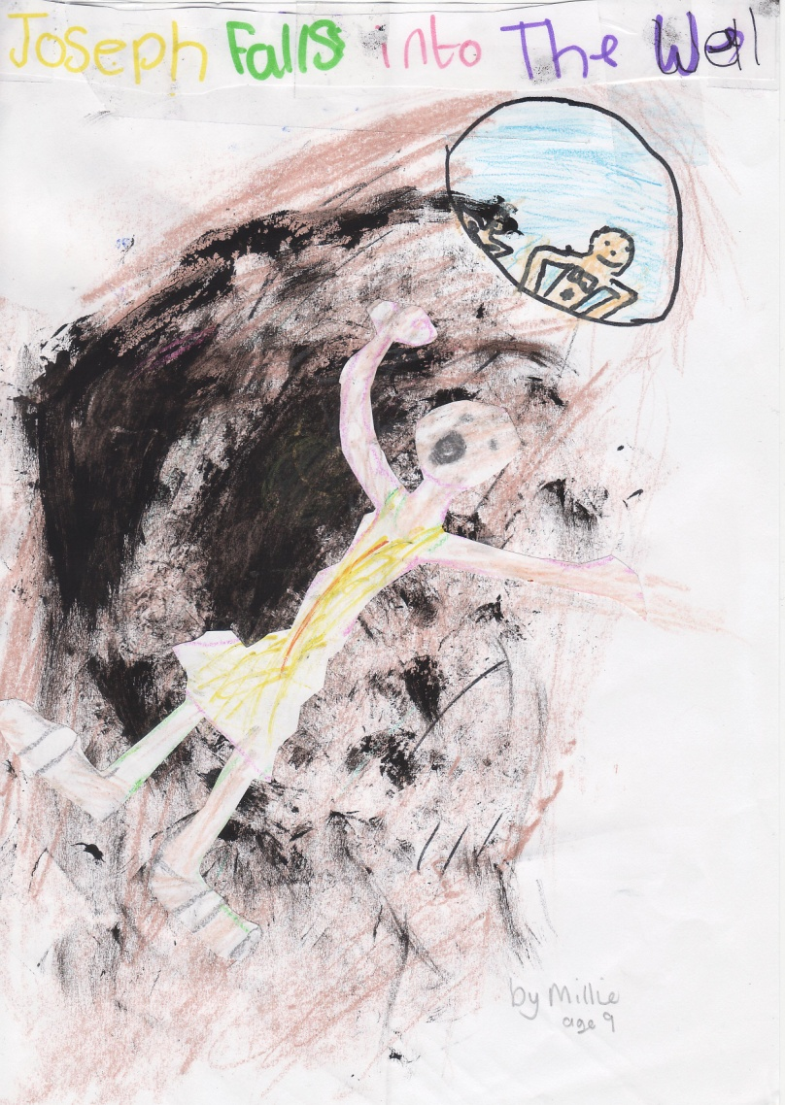
2nd Sept 2012

Trinity 13

Anthem

Teach Me O Lord Attwood
Sent by the Lord Weaver

Weekly Services
Sundays:
10am - Family Communion
Wednesdays:
9.30am - Holy Communion

Weddings and Baptisms
by appointment


St. Aidan’s Cof E Parish Church
Manchester Rd Rochdale OL11 2EL
Vehicular Access OL11 3NH
www.staidan.org.uk
Gospel Reading
Mark 7 1-8,14-15,21-23

NEXT WEEK!! – Today is last chance for tickets.
BLAST FROM THE PAST
Saturday 8th Sept 7pm for 7.30pm
A musical treat followed by a 2 course meal with tea or coffee. Bring your own drinks (glasses provided). Admission by ticket only (£10) from Keith & Jane – 648955, or Ken & Joan Davies - 658228

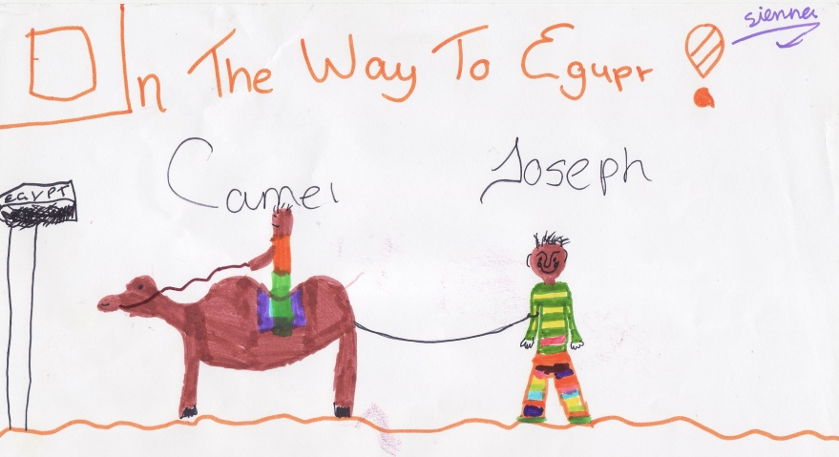
From the Story of Joseph Art Gallery on the website and in the Robinson Room by members of the Children’s Groups.
METAL THEFTS There have been thefts of lead from the church roof in the past fortnight. This caused extensive problems last week with the disruption to the power supply to the Hall and then water damage in the Organ Loft and Chapel discovered after the heavy rain last weekend. The cost of repairs will not be fully covered by Insurance.

Coffee and Tea is served in the Hall after the Service

INTERCESSIONS
Please add names for the Intercessions in the book at the back of Church.

Welcome to St Aidan’s Church
We are a friendly caring church.
If we can help you in any way, please speak to the Vicar, Sidespersons or any of the Church Officers.

GIFT AID LEGISLATION
If you are a taxpayer and don’t at present make use of the weekly envelope scheme, kindly use the Gift Aid Envelopes you will find near your seat. We will then be able to claim 25p for every £1 you give. Please remember to fill in your name and address.
DUTIES NEXT WEEK: 9th September - Trinity 14

Sidespersons | D&M Benjamin, A Parry, M Swarbrick
Coffee rota | J Davies, P Stock, J Stopforth
Hall preparation | B Hassall, A Clarke
Junior Church | See rota in church
Open Church | See rota in church
Church Cleaning

Please email notices to newsletter@staidan.org.uk by noon on Weds and if you wish this notice sheet to be emailed to you every week, please contact newsletter@staidan.org.uk
Please send items for the website to webmaster@staidan.org.uk
JUNIOR CHURCH: our Children’s Groups meet in the Hall
during the Morning Service: Kindergarten (3-6)
Adventurers & Explorers (7 – 14)

Heritage Open Days 2012

St Aidan’s will be open on Friday 7th, Saturday 8th and Sunday 9th 2-4pm as part of the national scheme. Please come along to have a look around church and have a coffee.
This year we hope to have a display about our Father Willis Organ as we will be celebrating the 60th Anniversary of the Dedication of the Organ on Sunday 23rd September.
Volunteers are needed for the three days. Please sign the list at the back of church.

----------------------------------------------------------------------------------
For more details about other Heritage Open days in the deanery see website www.heywoodandmiddletondeanery.org.uk
.
ALPHA COURSE AT BAMFORD CHAPEL commences Monday 24th September at 7pm for 12 weeks. There is a meal, DVD & a chat. It is a free course with a donation towards food. See Oliver’s Mum (aka Rachel!) or poster for more info. Launch event Mon 17th Sept 7pm, Queens Park Cafe. Course open to anyone who hasn’t attended an Alpha course before.
OPEN CHURCH
Thanks to those who have 'church sat' in recent months, we have had some interesting visitors.
There are a number of spaces in the months to the end of the year. Please have a look at the rota at the back of church near the Visitors Book and enter your name where you would be prepared to do a session. Ideally there should be two sitters per session.
Many thanks. Keith Lloyd (648955)

ST AIDAN'S BANQUETS 2012
Banquet Rehearsals start next Sunday – September 9th at 7-9 pm in the Hall. If you would like to be involved in any way in the entertainment please come along and find out what is happening. See Sheila Tolley if you can help with food preparation or washing up.

Watercolour Painting Group : The group will hopefully resume operations on Monday, 10th September at 12.45p.m. As previously stated, numbers are small and so we would welcome any prospective newcomers. Please let Malcolm Hardy know (410093 or malchardy@sky.com) if you intend to join us.
MEN'S GROUP
The next get-together of the Men's Group will be on Wed 3rd Oct.

